2021

Planning & Management

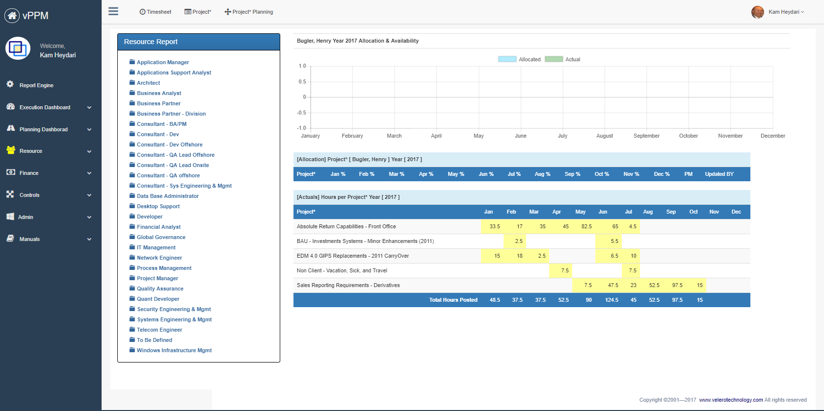

**Student Names:**

Shemal Shah

**Assignment Name:**

Spotify

Contents

2. Company Strategy & Scorecard 2

2.1. Company Background 2

2.2. SWOT Analysis 2

2.3. Scorecard 3

2.4. Reference information 4

3. Project Definition 4

3.1. Project Business Case 4

3.1.1. Project overview 4

3.1.2. Business issues/opportunities 4

3.1.3. Project Business Goals 5

3.2. Primary Project Objectives 5

3.3. Project Benefits 5

3.4. Primary Project Deliverables 6

3.4.1. Project milestones 6

3.4.2. Project Interdependencies and Inputs 6

3.5. Project Conditions 7

3.5.1. Assumptions 7

3.5.2. Risks and Issues 7

3.5.3. Project Constrains 7

3.6. Project Critical Success Factors (Key Performance Indicators) 8

3.7. Scope 8

3.8. Strategy Matrix 9

3.9. Work Breakdown Structure 10

3.10. Resource and Cost Estimate 10

3.10.1. Cost 10

3.10.2. Resource Needed 11

3.11. Roles & Responsibility Matrix 12

3.12. Project Structure 13

3.13. Resource requirement Matrix 14

3.14. Project Schedule 15

# Company Strategy & Scorecard

## Company Background

* With Spotify, it’s easy to find the right music or podcast for every moment – on your phone, your computer, your tablet and more.
* There are millions of tracks and episodes on Spotify. So whether you’re behind the wheel, working out, partying or relaxing, the right music or podcast is always at your fingertips. Choose what you want to listen to, or let Spotify surprise you.
* You can also browse through the collections of friends, artists, and celebrities, or create a radio station and just sit back.

## SWOT Analysis

|  |  |
| --- | --- |
| Strength   * High level of customer satisfaction * Successful track record of developing new products * Highly skilled workforce through successful training and learning programs. | Weakness   * The profitability ratio of Electronic Arts (EA) is below the industry average. * Limited success outside core business * Large number of customers has increased load time and made online platforms slower |
| Opportunity   * New customers from online mobile channel * Stable free cash flow provides opportunities to invest in adjacent product segments. * Fight between Microsoft and Sony will increase their value if they want to make EA exclusive and under them | Threats   * New technologies developed by other competitor (e.g.: Metaverse) could be a serious threat to the industry in medium to long term future. * Shortage of skilled workforce in future * Rising raw material can pose a threat to the Electronic Arts (EA) profitability. |

## Scorecard

## Reference information

* <https://s22.q4cdn.com/894350492/files/doc_financials/2022/q3/Q3-FY22-Earnings-Deck-vFinal.pdf>
* <https://ir.ea.com/home/default.aspx>

# Project Definition

Project Name: Introduce Cloud Mobile Gaming platform

## Project Business Case

### Project overview

Electronic Arts is a global leader in digital interactive entertainment. Headquartered in Redwood City, California. Where EA has more than 450 million players playing hundreds of games in their vast library from Sims City to FIFA and waiting for them to release new games. There are 3.5 billion mobile players, 2.7 billion console players and 1.75 pc players playing various games to compete and enjoy playing them. We need to introduce cloud mobile gaming where our players can engage and enjoy anytime, anywhere, and on any device.

### Business issues/opportunities

* A Cloud Mobile Gaming platform support
* Add well-established games to free mobile platform
* Microtransactions are a good and stable form of revenue
* Games by EA should be as popular as Wordle

### Project Business Goals

|  |  |
| --- | --- |
| ID | Objective/Goal |
| O1 | Have about 10 million new players on the new platform |
| O2 | Revenue of Mobile Gaming should increase by 20% |
| 04 | $50 million of revenue through in game microtransactions |

## Primary Project Objectives

[Replace this text with a list of the key project elements that further define and support the project business goal and are in scope for the overall project.]

## Project Benefits

Describe the key benefits from implementing this project.]

* [Benefit]
* [Benefit]

## Primary Project Deliverables

### Project milestones

|  |
| --- |
| Milestone 1 |
|  |
| Milestone 2 |
|  |
| Milestone 3 |
|  |

### Project Interdependencies and Inputs

|  |
| --- |
| Project Interdependencies and Inputs |
| [Replace this text with an outline of any other projects in process or planned that have a relationship to this proposed project. Include a list of what inputs those projects may have to this project development.] |

## Project Conditions

Includes your project assumptions break them down by (resources, delivery, budget, scope, schedule, methodology, technology, and architecture & design)

### Assumptions

[Identify all known assumptions that apply to this project.]

| **ID** | **Item** |
| --- | --- |
| A1 | This project works with internal flights Because Internet access is available on internal flights so that the customer can track the bag |
| A2 |  |
| A3 |  |
| A4 |  |

### Risks and Issues

Identify risks and issues in the following forms.

|  |  |  |  |
| --- | --- | --- | --- |
| **Risk** | **Prob** | **Impact** | **Mitigation** |
|  |  |  |  |
|  |  |  |  |
|  |  |  |  |
|  |  |  |  |
|  |  |  |  |

### Project Constrains

[Replace this text with an outline of all known constraints that apply to this project.]

## Project Critical Success Factors (Key Performance Indicators)

[Replace this text with an outline of all known critical success indicators that apply to this project.]

## Scope

Define what is in- and out- of scope for your project.

#### In scope

**Sample**: The In-Scope functions will be assessed from both an interim and future state perspective, incorporating the specific organization complexities relative to global lines of business, asset classes, reporting, and operational processes. The following capabilities are agreed to be in-scope for the data assessment and target state design:

| **ID** | **Type** | **Definition** |
| --- | --- | --- |
| S1 | Customer | Definition of what is in the project scope as far as customer is concerned |
| S2 | Airline |  |
| S3 | Inventory |  |

#### Out of Scope

**Sample**: The following areas are agreed to be out of scope for the Data Assessment:

| **ID** | **Item** |
| --- | --- |
| OS1 | Organization changes … |
| OS2 |  |
| OS3 |  |

## Strategy Matrix

Define complete strategic matrix for your project using strategic matrix table – Identify 4 strategies for the organization – See lecture material and PMI material.

|  |  |  |  |  |
| --- | --- | --- | --- | --- |
| Project Objectives | Strategies | | | |
| **Strategy** | **Strategy** | **Strategy** | **Strategy** |
|  |  |  |  |  |
|  |  |  |  |  |
|  |  |  |  |  |
|  |  |  |  |  |
|  |  |  |  |  |
|  |  |  |  |  |
|  |  |  |  |  |

## Work Breakdown Structure

Define your work breakdown structure for your project – See Lecture material

## Resource and Cost Estimate

Using the following format define your resource (Excluding FTE Cost) cost estimates.

### Cost

|  |  |  |  |
| --- | --- | --- | --- |
| Cost Description | Schedule (year) | Amount | Note |
|  |  |  |  |
|  |  |  |  |
|  |  |  |  |
|  |  |  |  |
|  |  |  |  |
|  |  |  |  |

### Resource Needed

|  |  |
| --- | --- |
| Resource Type | Note |
|  |  |
|  |  |
|  |  |
|  |  |
|  |  |
|  |  |

## Roles & Responsibility Matrix

Define roles and responsibilities using RACI model for all participating resources.

|  |  |  |  |  |  |  |  |  |  |
| --- | --- | --- | --- | --- | --- | --- | --- | --- | --- |
| **Project Team**  **|**  **Area of Responsibilities** | |  |  |  |  |  |  |  |  |
|  |  |  |  |  |  |  |  |  |  |
|  |  |  |  |  |  |  |  |  |  |
|  |  |  |  |  |  |  |  |  |  |
|  |  |  |  |  |  |  |  |  |  |
|  |  |  |  |  |  |  |  |  |  |
|  |  |  |  |  |  |  |  |  |  |
|  |  |  |  |  |  |  |  |  |  |
|  |  |  |  |  |  |  |  |  |  |
|  |  |  |  |  |  |  |  |  |  |
|  |  |  |  |  |  |  |  |  |  |
|  |  |  |  |  |  |  |  |  |  |
|  |  |  |  |  |  |  |  |  |  |
|  |  |  |  |  |  |  |  |  |  |
|  |  |  |  |  |  |  |  |  |  |
|  |  | R | A | C | I |  |  |  |  |
|  |  |  |  |  |  |  |  |  |  |
| **Responsible** | | People or stakeholders who are the "doers" of the work. They must complete the task or objective or make the decision. Several people can be jointly *Responsible*. | | | | | | | |
| **Accountable** | | Person or stakeholder who is the "owner" of the work. He or she must sign off or approve when the task, objective or decision is complete. This person must make sure that responsibilities are assigned in the matrix for all related activities. ***Success requires that there is only one person Accountable.*** | | | | | | | |
| **Consulted** | | People or stakeholders who need to give input before the work can be done and signed-off on. These people are "in the loop" and active participants. | | | | | | | |
| **Informed** | | People or stakeholders who need to be kept "in the picture." They need updates on progress or decisions, but do not need to be formally consulted, nor do they contribute directly to the task or decision. | | | | | | | |

## Project Structure

Define your project structure considering information provided in the project mandate.

## Resource requirement Matrix

Define resource requirement matrix per work pages using the format that was provided to you in the class and for your group assignment.

|  |  |  |  |  |  |  |  |  |  |  |  |  |
| --- | --- | --- | --- | --- | --- | --- | --- | --- | --- | --- | --- | --- |
| Resource/Month | 1 | 2 | 3 | 4 | 5 | 6 | 7 | 8 | 9 | 10 | 11 | 12 |
|  |  |  |  |  |  |  |  |  |  |  |  |  |
|  |  |  |  |  |  |  |  |  |  |  |  |  |
|  |  |  |  |  |  |  |  |  |  |  |  |  |
|  |  |  |  |  |  |  |  |  |  |  |  |  |
|  |  |  |  |  |  |  |  |  |  |  |  |  |
|  |  |  |  |  |  |  |  |  |  |  |  |  |
|  |  |  |  |  |  |  |  |  |  |  |  |  |

Using Velero product include the estimated cost (Screen shot)

## Project Schedule

Using the following format to define complete project schedule using PMI (initiation, Planning, Execution, Monitoring and Control and Closure.) Start date 1/1/2022. Make your project schedule as realistic as possible please. Identify all the dependencies, using task ID.

Input the information into Velero and generate the Gantt chart. Include the Gantt chat screen shot.

|  |  |  |  |  |  |
| --- | --- | --- | --- | --- | --- |
| Task ID | PMI | Tasks/Milestone | Start | End | Dependency |
| 1 | Initiation |  | 1/1/2020 |  |  |
|  |  |  |  |  |  |
|  |  |  |  |  |  |
|  |  |  |  |  |  |
|  |  |  |  |  |  |
|  |  |  |  |  |  |
|  |  |  |  |  |  |
|  |  |  |  |  |  |
|  |  |  |  |  |  |
|  |  |  |  |  |  |
|  |  |  |  |  |  |
|  |  |  |  |  |  |
|  |  |  |  |  |  |
|  |  |  |  |  |  |
|  |  |  |  |  |  |